AGREEMENT FOR UNDERGROUND ELECTRIC SERVICE

[Insert subdivision name and section number here]

The State of Texas §
§
County of _______________ §

This Agreement for Underground Electrical Service (“Agreement”) is made and entered into by and between CenterPoint Energy Houston Electric, LLC, a Texas limited liability company, its successors and assigns (“Company”) and, [Insert Legal Name of Owner], its successors and assigns (“Owner”).

WITNESSETH:

WHEREAS, Owner owns and is developing a single family residential property that is partitioned into single lots, tracts, or parcels of land known as [Insert subdivision name and section number here], a subdivision containing at least [Insert numerical value] lots, which is located in the [Insert survey name and abstract number here] (“Subdivision”). The part of the Subdivision covered by this contract will be fully shown on a plat thereof which Owner agrees to and will record in the Map Records of [Insert name of county here] County, Texas;
WHEREAS, pursuant to its tariff for retail delivery service, Company customarily extends and furnishes electric service by and through an overhead electric delivery system containing primary lines, secondary lines, and service lines; and,
WHEREAS, in lieu of Company’s standard overhead electric delivery system, Owner has requested that Company installs within the Subdivision the underground electric cables, and other facilities described and identified in Section 1 below, which Company is willing to do under the terms and conditions in this Agreement.

NOW THEREFORE, it is agreed as follows:

- The underground electric distribution system (“Underground Distribution System”) shall be installed in easements provided therefore and shall consist of, but not be limited to, overhead primary feeder circuits constructed on poles, single or three phase, and underground primary and secondary circuits, pad mounted or other types of transformers, junction boxes, and any such other appurtenances deemed necessary by Company to make underground service available to the permanent residential dwelling units.

- Owner agrees, at Owner’s expense, to (a) accurately pin all lot, block, and reserve corners with iron rods not less than ½-inch in diameter or iron pipes not less than ¾-inch in outside diameter and not less than 24-inches long (longer rods or pipes will be used in soft soil to insure the stability of the monument); (b) identify all lots with stakes or laths marked with lot numbers; (c) clear all easements of trees, stumps, permanent fencing, and other obstructions that would interfere with Company’s overhead distribution pole line or underground cable installation; and, (d) develop all easements and rights-of-way to final grade level suitable for machine trenching before Company starts its installation. Owner agrees that before Company can install any electrical underground facilities, Owner shall, in addition to any other requirements in this Agreement: construct all streets, alleys, and sidewalks, whether public or private,; construct paved infrastructure; erect street signs; and complete all drainage inlets and manholes.

Upon Company’s completion of the installation of the Underground Distribution System, grade shall be kept substantially in conformance with the original grade. In the event the changes to the final grade level by Owner negatively impacts the operations of the Underground Distribution System, affects the integrity of the Underground Distribution System, or affects the safe operating clearances of the Underground Distribution System, Owner shall be allowed 14 calendar days to resolve grade level conflicts. In the event Owner does not resolve the final grade impacts within 14 calendar days, then Company shall facilitate all relocations or modifications to the Underground Distribution System, to occur at the expense of Owner. In any of the herein listed situations where Company incurs any costs, Owner shall pay any and all costs to Company within 30 business days. The parties understand that from time-to-time it may be appropriate for Owner to exceed the standard 14 calendar day allowance due to emergency operating events or electrical outage events, and the parties will reasonably accommodate one another to allow Owner reasonable additional time as appropriate.

Owner further covenants, agrees, and clarifies that it will keep all easements unobstructed, including, but not limited to, those easements dedicated by recorded plat and labeled “Public Utility Easement,” “Utility Easement,” and/or “Aerial Easement” on the plat, and easements created by separate instrument, including, but not limited to, those created by and through covenants and/or deed restrictions. Company shall also have rights of ingress and egress to and from easement area(s), private or public streets, alleys, and sidewalks, together with reasonable working space on all lots, reserves, and open spaces, for the purposes of erecting, installing, operating, maintaining, replacing, inspecting, and removing utility facilities, together with the additional right to remove from said easement and land immediately adjoining thereto all bushes, trees, landscaping and parts thereof, or other structures or improvements which are within, protrude, bisect, encroach, or overhang into said easement areas and, if in the sole opinion of Company, endanger or may interfere with the efficiency, safe and proper operation, and maintenance of any utility facilities. Further, in the event dead or dangerous trees exist within the fall range of overhead electrical facilities, then Company shall have the right to take down said trees based on Company’s sole discretion. In addition to the above, from time to time the Company will have to access electrical transformers and pedestals. During said access ‘hot stick limits’ require additional safe operation space, which is illustrated immediately below or on next page:

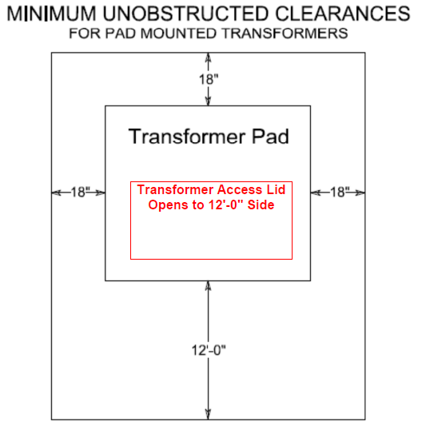

- Absent prior written authorization by the affected utilities or Company, all utility and aerial easements must be kept unobstructed from any non-utility improvements or obstructions by the respective property owner(s). Any unauthorized improvements or obstructions may be removed by any public utility or Company at the property owner’s expense. While wooden posts and paneled wooden fences along the perimeter and back-to-back easements and alongside rear lots lines are permitted, they too may be removed by public utilities or Company at the property owner’s expense should they be an obstruction. Public utilities or Company may put said wooden posts and paneled wooden fences back up, but typically will not replace with new fencing.

- Owner hereby restricts the Subdivision to underground electric service and the parties agree and stipulate that the filing of this instrument in the Deed Records of [Insert County Name where recorded here] County, Texas will have the same force and effect as a deed restriction running with the tract of land to the effect that only underground electric service will be furnished thereto, except such overhead facilities as shown on the facility plan layout agreed to and approved by both parties thereon. Areas in the Subdivision not served from the Underground Distribution System will be served by the Company from the usual overhead electric distribution system. Areas outside of the Subdivision are not covered by this Agreement, unless Owner has dedicated through separate agreements for DEDICATION OF UNOBSTRUCTED DRY PUBLIC UTILITY AND AERIAL EASEMENTS along the perimeter or proposed platted boundary, in which case those agreements attach, tack, and run with this Agreement.

- The electric service furnished under this Agreement will be of the type described by the Company as single phase, 120/240-volt, three wire, 60-cycle alternating current for lighting and power.

- Company will make underground electric service available to permanent residential dwelling units in the Subdivision under Company’s standard terms and conditions, or standard electric service agreements, at its regular published applicable rates at the nominal secondary service voltage specified in Section 5 hereof, and at the load terminal of the individual meters.

- Company reserves the right to construct underground and overhead electric primary feeder lines within dedicated Public Utility or Utility Easements and/or Aerial Easements, including, but not limited to, crossing open spaces, crossing reserves, crossing sanitary sewer easements, crossing waterline easements, crossing storm sewer easements, crossing green belts or landscape easements, crossing fire hydrant easements, private or public streets, alleys, and sidewalks, or acquired easements otherwise acquired within the Subdivision, or elsewhere as Company may determine in its sole discretion is necessary, for the furnishing of the Underground Distribution System or to meet Company’s general area requirements. The above underground and overhead electric primary feeder line locations shall be mutually agreed to by both Owner and Company by either Underground Distribution System layouts, or facility layouts or plans. At Company’s option, those lots adjacent to such overhead distribution facilities may be served from the overhead distribution system. Where overhead service is furnished for electrical distribution purpose, the distribution system will be installed in Utility and Aerial Easements provided therefore and shall consist of overhead primary and secondary circuits constructed on poles equipped with transformers and such other appurtenances as Company deems necessary to make overhead service available. Company shall, concurrently with the installation of its facilities, have title to and complete control over the facilities to be installed by it.

- In consideration of Company’s installing the Underground Distribution System in lieu of its standard overhead electric system, Owner hereby grants easements to Company for the Underground Distribution System and the overhead electric system in, over, under, and across those parts of the Subdivision that are necessary for the purposes of installation, operation, inspection, repair, maintenance, replacement, removal, and enlargement of the Underground Distribution System. All of Company’s distribution lines and equipment are to be installed in the locations that are mutually acceptable to the parties hereto. In the event any action by Owner requires relocation of all or any part of Company’s facilities, Owner agrees to reimburse Company in full for all of Company’s expenses incurred in effecting such relocation.

- Owner warrants that it is the record owner of the Subdivision, that it has the rights to enter into this Agreement, and that the easements and use restrictions granted herein are superior to any other interests in the Subdivision, including, but not limited to, the interest of a lien holder, mortgagee, or trustee under a deed of trust, if any.

- Owner is responsible for all applicable costs for any additional Underground Distribution System loop(s) that are requested by Owner, and Owner shall pay these costs as follows: (a) Owner must provide Company with a security payment or, (b) Owner must provide a non-cash alternative.

- Company agrees and declares that nothing contained in this Agreement is intended to or will constitute a lien against the Subdivision, and Company does not have or claim any lien against the Subdivision under this Agreement.

- This Agreement, and the benefits and obligations hereof, will be binding upon and inure to the benefit of the parties hereto, their respective heirs, successors, and assigns, as the case may be, and this Agreement will not be assigned by either party without the consent of other party.

- Owner agrees to coordinate the construction of buildings, structures, improvements, and other utilities in such a manner so as to avoid conflict or interference with the Company’s installation of its facilities. In the event Company is prohibited from the installation of its facilities due to the untimely construction of an improvement(s) then Owner agrees to reimburse Company for the additional cost to the Company resulting from such interference.

- Owner agrees to allow electrical service connection, also known as service drops, to be made from adjoining lots or home sites into any of said easements.

- If Owner selects *Option 1 below or fails to select either Option below, the following terms of this Section 15 are part of this Agreement:

Owner may provide and install conduit for all street, alley, or sidewalk crossings for the installation of Company’s facilities including gas sleeves, distribution, streetlights, and related communications facilities, provided all conduits shall be installed according to the Company’s standards and location specifications. Company’s representatives shall inspect the installation of the conduits. In the event the street, alley, or sidewalk crossing conduit has not been installed to Company’s standards and location specifications at the time of the final construction walk by Company and Owner representatives, street, alley, or sidewalk bores will be required. Upon the completion of the final inspection, Company shall assume ownership of all conduits.

- If Owner selects *Option 2 below, the following terms of this Section 16 are part of this Agreement:

Owner may, at its sole discretion, request that Company’s contractor install the street, alley, or sidewalk bores. Although all street, alley, and sidewalk bores will be made in accordance with applicable city or county standards, Owner acknowledges that bores in certain soil conditions can result in cracks to the pavement over time. OWNER SHALL INDEMNIFY AND HOLD HARMLESS COMPANY AND ITS EMPLOYEES FROM ANY AND ALL DEMANDS, CLAIMS OR SUITS OF ANY KIND (INCLUDING REASONABLE ATTORNEYS’ FEES) ARISING IN FAVOR OF OWNER OR ANY THIRD PARTY FOR DAMAGE TO STREETS, ALLEYS, PAVEMENTS, PAVERS, DRIVEWAYS, AND/OR SIDEWALKS, WHICH RESULTS DIRECTLY OR INDIRECTLY FROM APPROPRIATE ACTIVITIES RELATED TO THE INSTALLATION OF THE STREET, ALLEY, OR SIDEWALK BORES MADE BY THE COMPANY, ITS AGENTS OR CONTRACTORS, EVEN WHERE CAUSED BY JOINT OR SOLE NEGLIGENCE OR FAULT OF COMPANY OR ITS AGENTS OR CONTRACTORS, BUT NOT THEIR WILLFUL MISCONDUCT OR GROSS NEGLIGENCE. This indemnification does not extend to damages caused to other property by Company, its agents, or contractors that is incidental to the work. (e.g., damage to an automobile legally parked on the street or alley). This indemnity applies to any boring done by Company for Owner at Owner’s request, including any additional boring deemed necessary on the final construction walk. Any and all additional bores required, as determined on the final construction walk (obstructions and bad location of installed conduit by Owner), will be at the cost of the Owner. All costs of bores associated with this development shall be paid in full prior to Company starting construction of facilities.

- Attached hereto are the following Standards for reference, whether applicable to this Subdivision or not. The applicable Standard(s) shall apply in the appropriate circumstances:
  - Distribution Standard 31-480 (Townhome Utility Layout Minimum Dimensions Based on Operational Guidelines)
  - Distribution Standard 31-485 (Rear Loaded Alley 12’-0” U.E. Minimum Dimensions Based on Operational Guidelines
  - Distribution Standard 31-486 (Townhomes & Rear Loaded Alley Conduit Install)
  - Distribution Standard 31-730 (Boring Guidelines in County Right of Ways) for when Company installs
  - Distribution Standard 31-740 (Conduit Install Guidelines in County Right of Ways) for when Owner installs
  - Distribution Standard 31-735 (Boring and Trenching Guidelines for State Right of Ways)

*OWNER SELECT STREET, ALLEY, or SIDEWALK BORE OPTION:
- Option 1. Owner shall provide and install all conduits at crossing location(s) to Company’s standards and specifications. Company’s representative shall inspect installation of all conduits. Inspection request shall be made no less than twenty-four (24) hours in advance (Mon. – Fri.; between 8:00AM and 5:00PM, holidays excluded) _Consultant's Office Phone (###) ###-####, Distribution Project Management of CenterPoint Energy Houston Electric, LLC, [SAP # SAP # ONLY] * Upon completion of final inspection, Company shall assume ownership of all conduit.
- Option 2. Owner shall pay cost of turnkey job to Company for installation of all conduits associated with street, alley, or sidewalk bore construction. Owner shall be responsible for the remittance of all payments prior to scheduling work for construction and shall indemnify the Company for all damages to the street, alley, or sidewalk caused by such installations as provided in paragraph 16 and 17 of this Agreement.

IN TESTIMONY WHEREOF, witness our hands to triplicate originals, executed on the date(s) shown in the acknowledgements, to be effective the _____ day of _________________________, 2021.

COMPANY  CenterPoint Energy Houston Electric, LLC  By:  Printed:  Title: | OWNER  By:  Printed:  Title:

The State of Texas §

County of Harris §

This instrument was acknowledged before me on this day of , 2021, by
, as ___________________ of Owner, on behalf of said Owner.

_________________________________
Notary Public

The State of Texas §

County of Harris §

This instrument was acknowledged before me on this ___ day of ___________________, 2021, by _____________________, as of Distribution Project Management of Center Point Energy Houston Electric, LLC, on behalf of said Company.

__________________________________
Notary Public

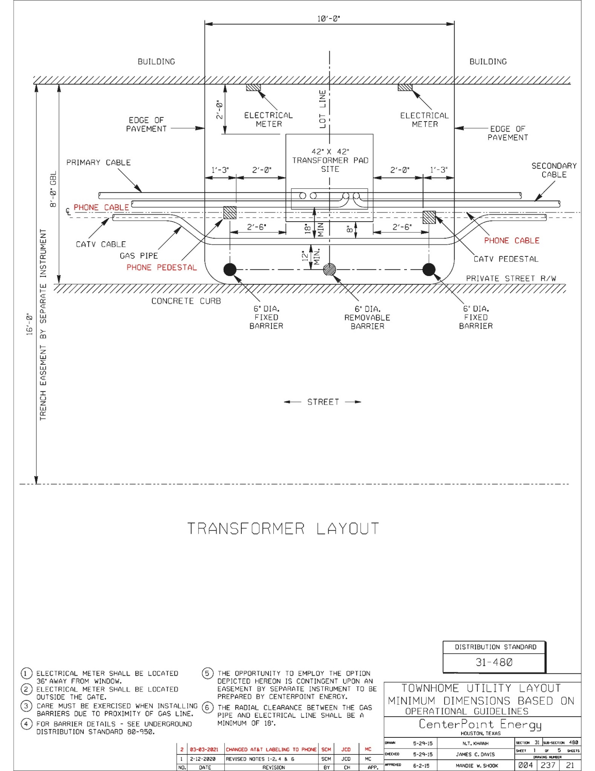
Distribution Standard 31-480 (Townhome Utility Layout Minimum Dimensions Based on Operational Guidelines)

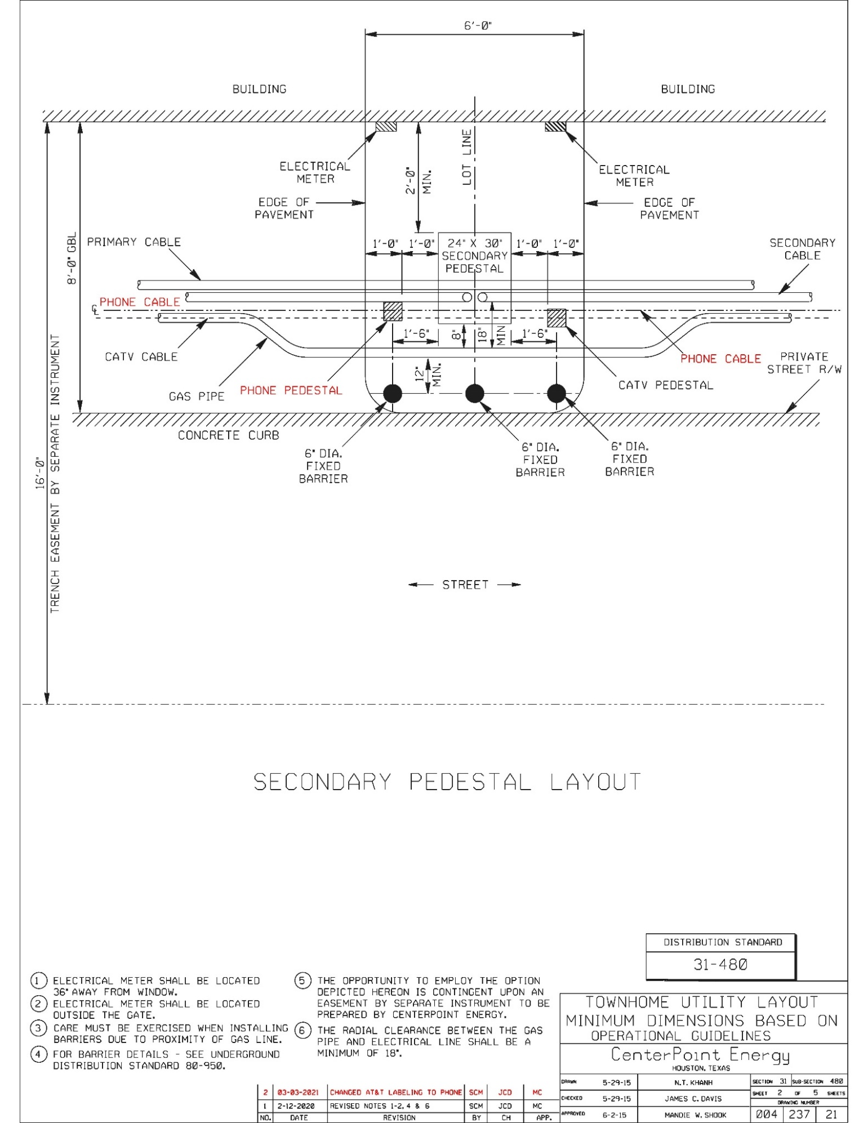
Distribution Standard 31-480 (Townhome Utility Layout Minimum Dimensions Based on Operational Guidelines)

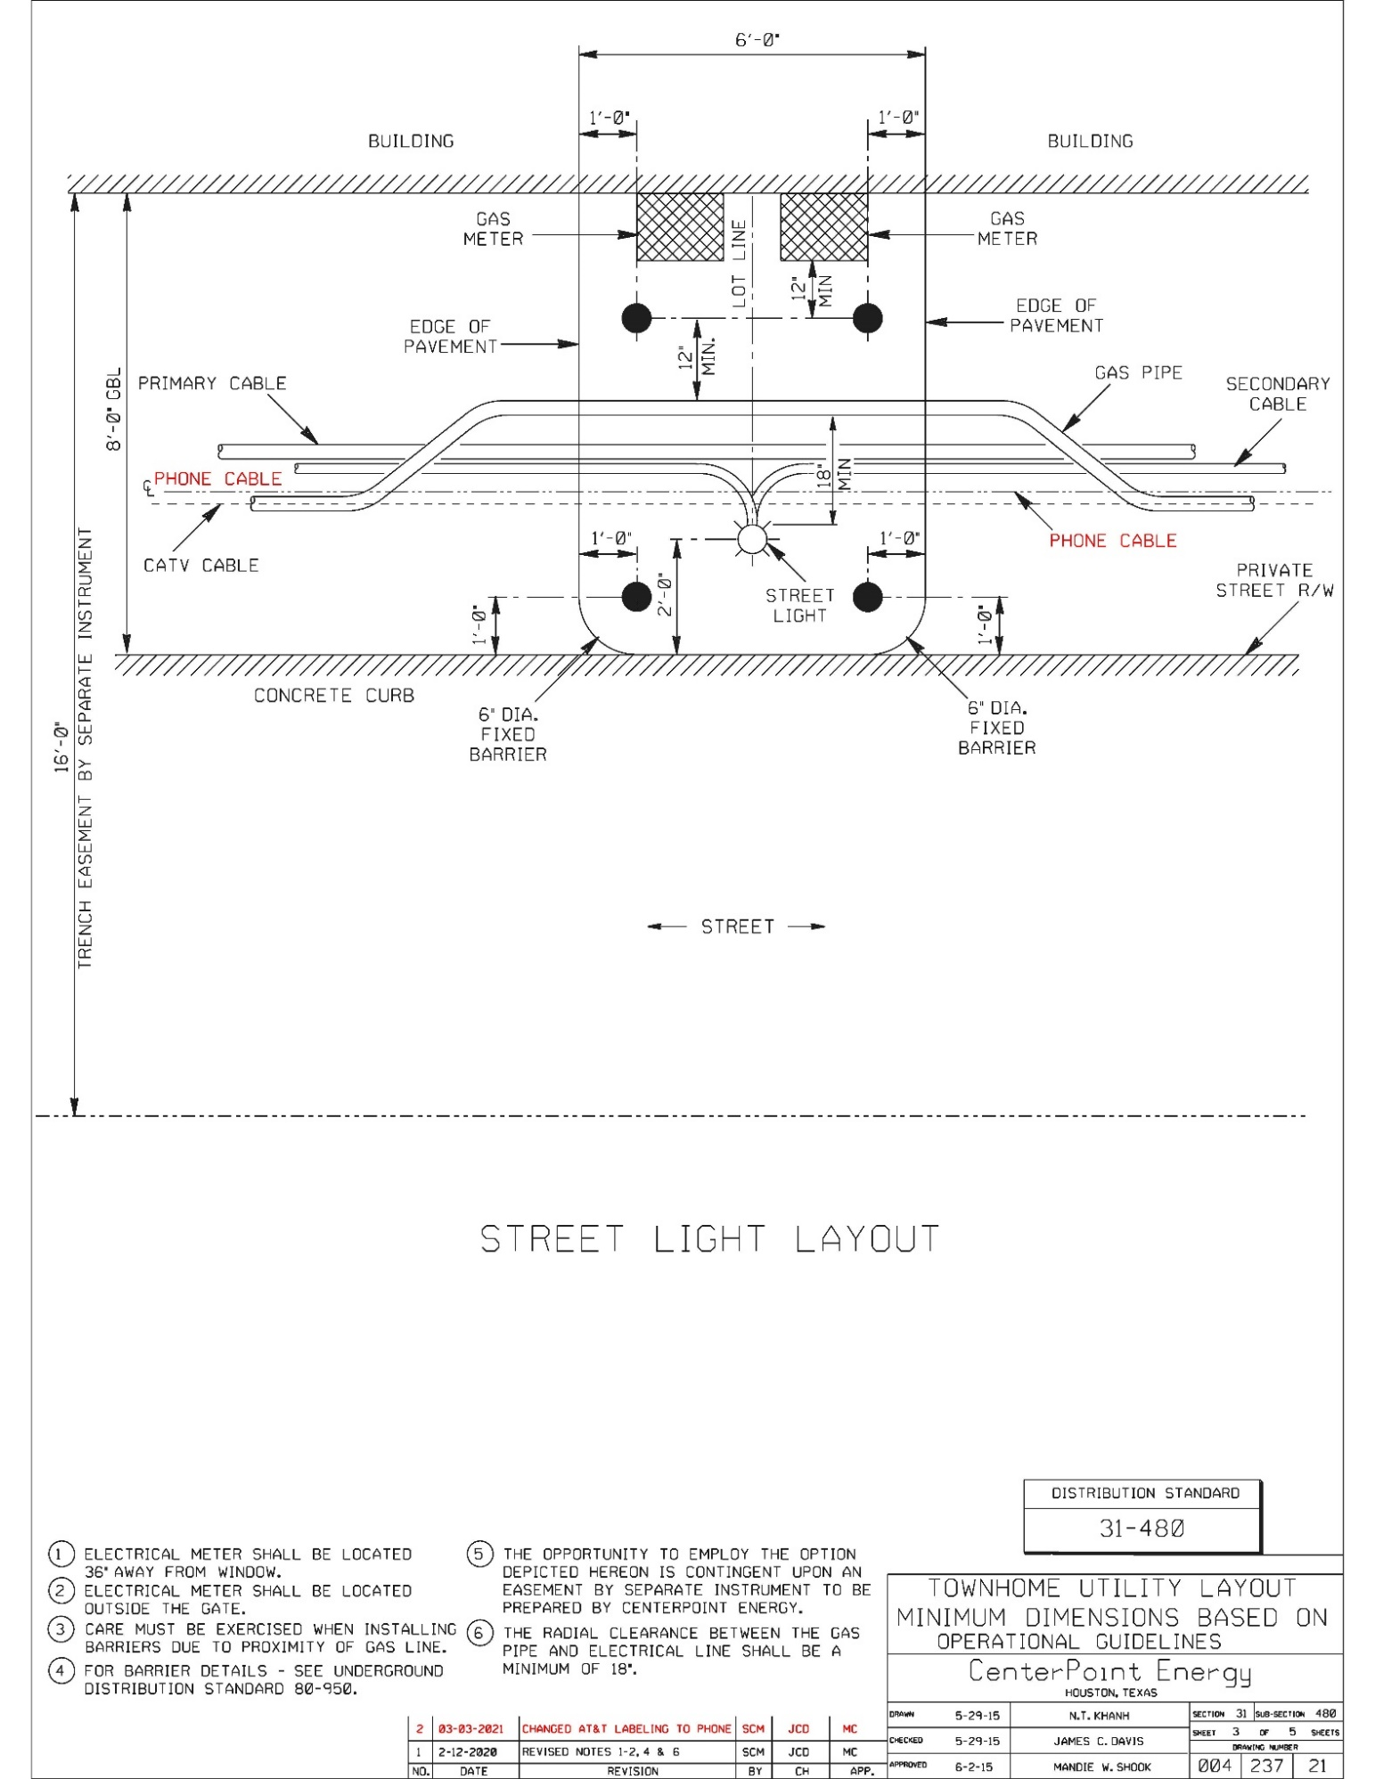
Distribution Standard 31-480 (Townhome Utility Layout Minimum Dimensions Based on Operational Guidelines)

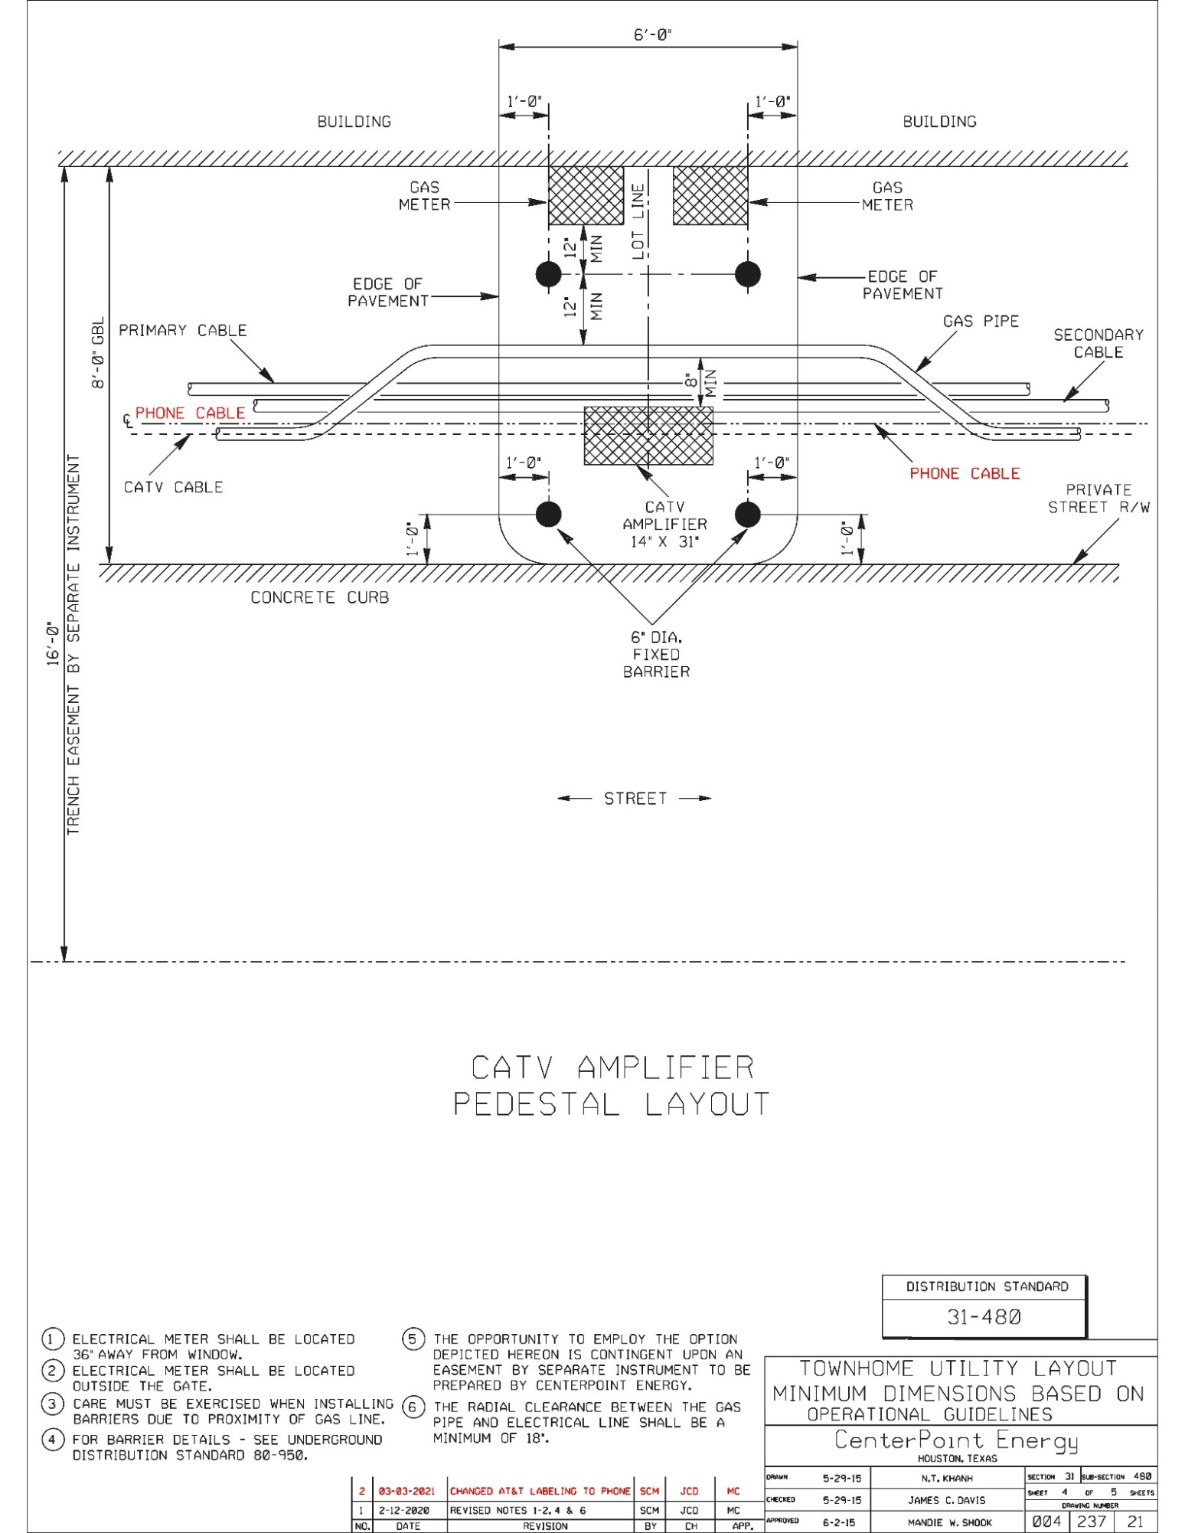
Distribution Standard 31-480 (Townhome Utility Layout Minimum Dimensions Based on Operational Guidelines)

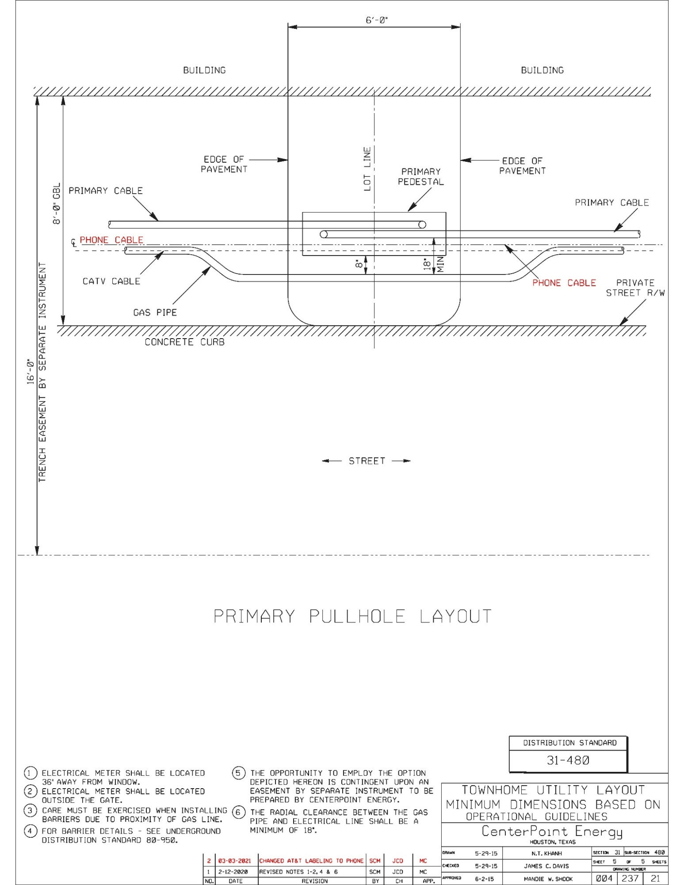
Distribution Standard 31-480 (Townhome Utility Layout Minimum Dimensions Based on Operational Guidelines)

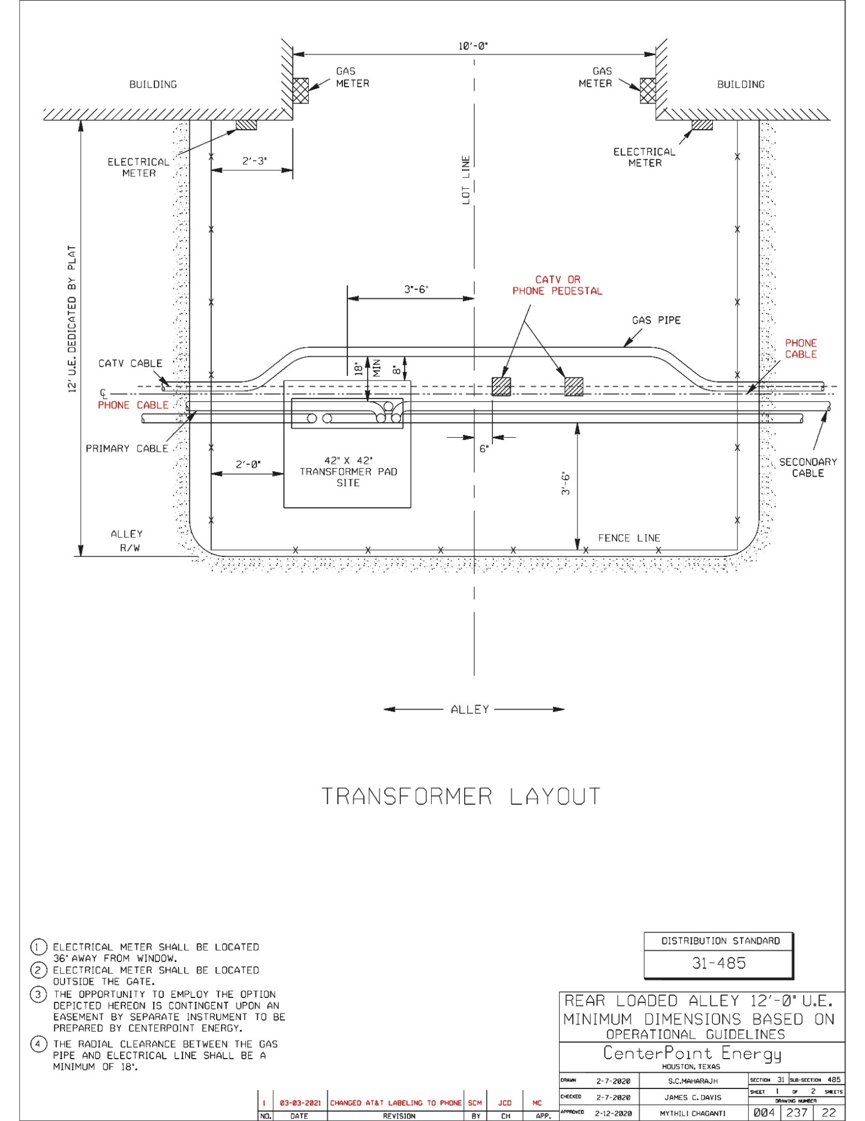
Distribution Standard 31-485 (Rear Loaded Alley Minimum Dimensions Based on Operational Guidelines)

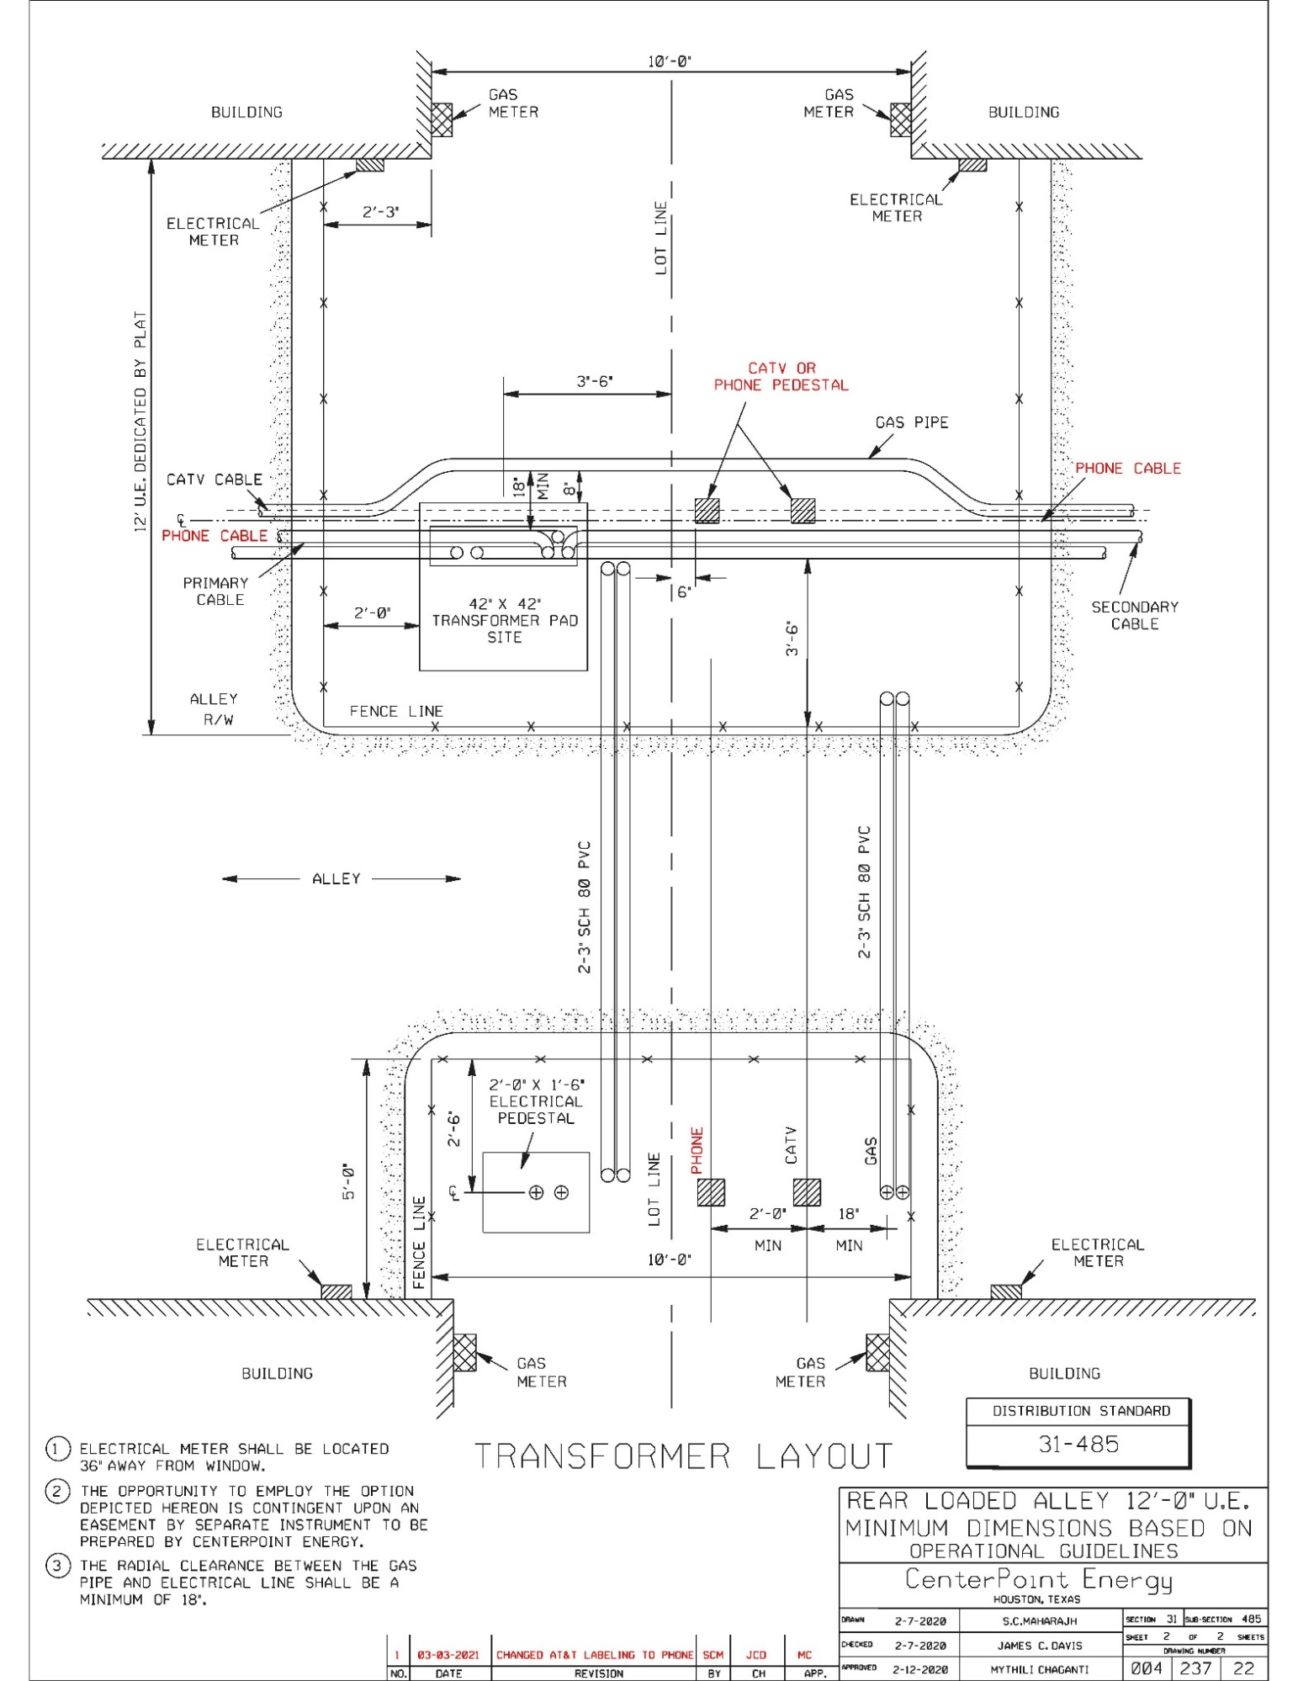
Distribution Standard 31-485 (Rear Loaded Alley Minimum Dimensions Based on Operational Guidelines)

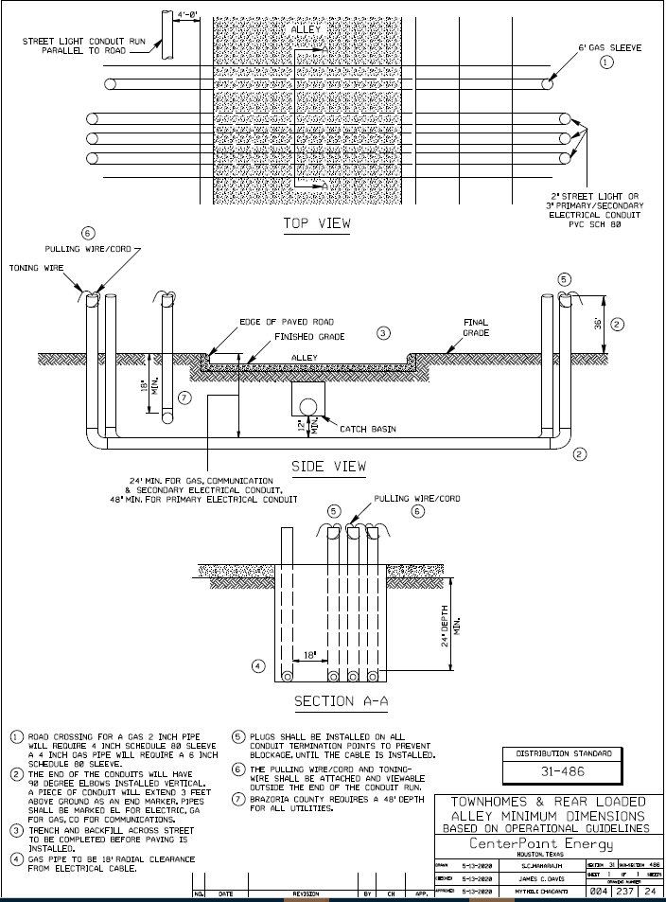
Distribution Standard 31-486 (Townhomes & Rear Loaded Alley Conduit Install)

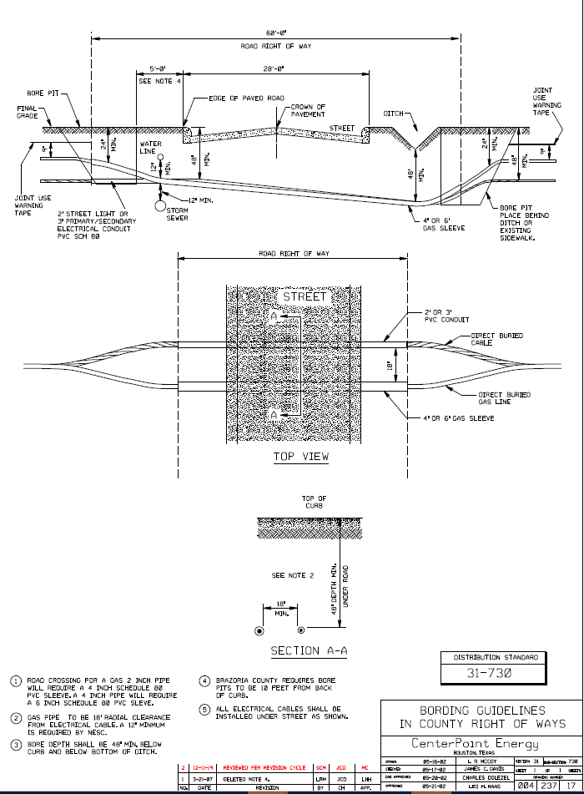
Distribution Standard 31-730 (Boring Guidelines in County Right of Ways) for when Company installs

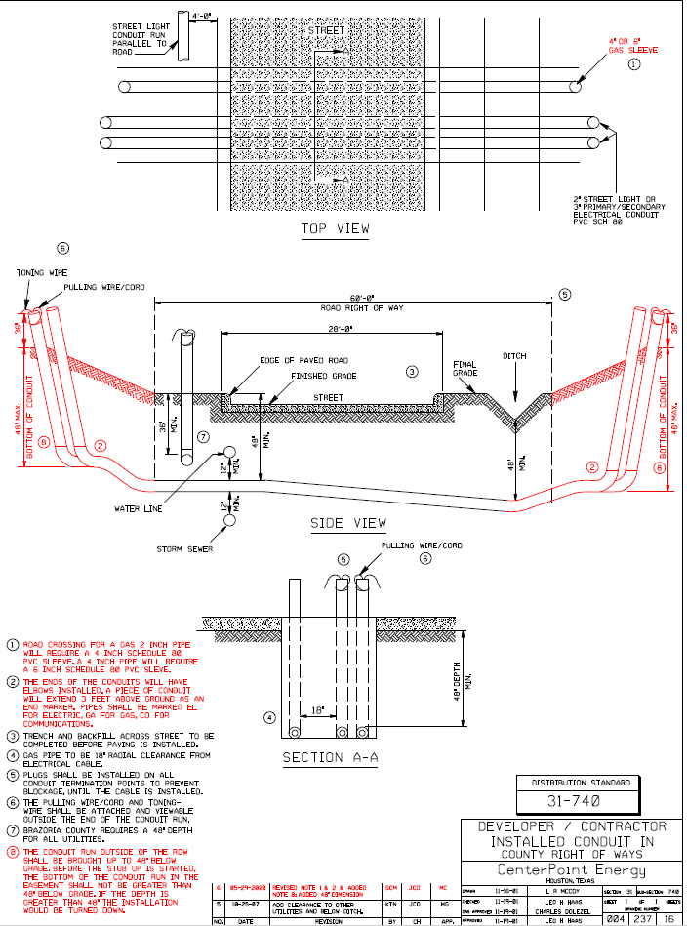
Distribution Standard 31-740 (Conduit Install Guidelines in County Right of Ways) for when Owner installs

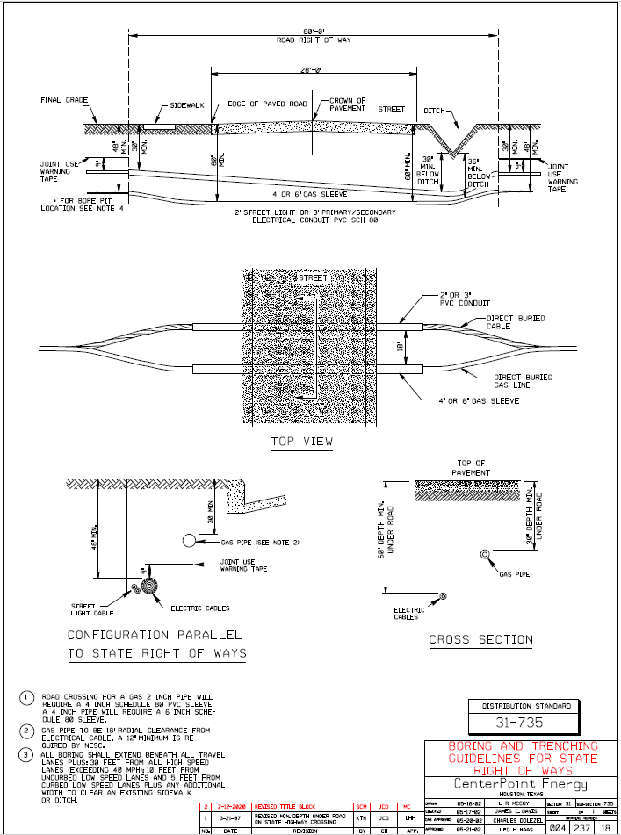
Distribution Standard 31-735 (Boring and Trenching Guidelines for State Right of Ways)

