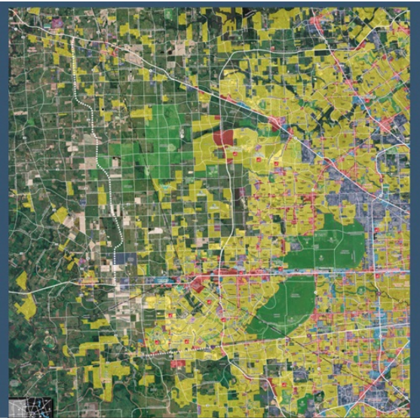
2017 Development Map Order Form
Thank you for your interest in the West Houston Association’s 2017 Development Map. To order a printed map please fill out the following information and return to Carmen Kumpula (contact information listed below). An invoice will be sent to you upon submission of this form. Thank you!

Map Order

Large Map: $120 per map

Size: 38” x 46” Quantity: ______

Small Map: $85 per map

Size: 25” x 21” Quantity: ______

Company Name:

Primary Contact:

Email
Name
Phone

Shipping Address:

Street Address
City/State/Postal Code

Billing Address:

City/State/Postal Code
Street Address

**Completed forms can be sent to Carmen Kumpula at carmen@westhouston.org or mailed to the address below:

West Houston Association
820 Gessner, Suite 1310
Houston, Texas 77024

